Attention:
Filming and photography in progress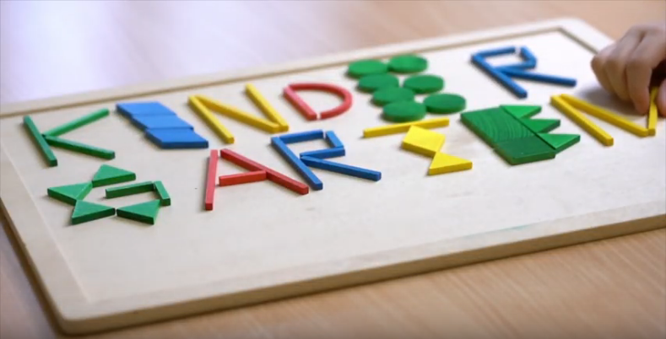
We want to immortalise the happiest moments of the Day of Kindergarten. To do this we take photos and/ or make films. The pictures and film clips will be used to document the event in the internet and possibly also by the press. If you do not want to be filmed or photographed please let the photographer present know.

Thank you for your understanding

[Name and contact details of the organiser]

